Innovative Machine Learning Approaches to Predict Soil CO₂ Emissions
Vincent Lu
BASIS Independent Fremont
Fremont California USA
Contact Email: funnymoose234@gmail.com
Abstract

Soil respiration represents the largest flux of carbon dioxide (CO₂) from the Earth's surface to the atmosphere. However, accurately predicting CO₂ emissions from soil respiration remains a significant challenge, and the influence of various environmental factors is not yet fully understood. This study develops machine learning models to predict CO₂ emissions from soil respiration and to evaluate the contributions of different environmental drivers. A new machine learning model, XGBoost, is introduced to estimate annual soil respiration (Rs) using spatial, temporal, climatic, and other independent variables. In addition, a deep neural network (DNN) is explored. The performance is compared with two baseline models, Random Forest (RF) and Gradient Boosting (GB), used in previous studies. Among the models, XGBoost achieves the best performance, surpassing RF. Conversely, the DNN model struggles to produce reliable results, primarily due to the limited sample size. Additionally, SHAP (SHapley Additive exPlanations) analysis is applied to enhance model explainability, quantifying the influence of individual features on model outcomes, both at the overall level and for specific predictions.

Keywords: Soil Respiration, Machine Learning, CO² emission, XGBoost Regressor, Model Explainability, SHapley Additive exPlanations, SHAP

1. Introduction
1.1 Issue statement
Soil respiration is the largest carbon dioxide (CO₂) flux from the Earth’s surface to the atmosphere. However, accurately forecasting carbon dioxide emission from soil respiration is still a daunting task. In addition, the impact of various environmental factors is not yet fully understood.
1.2 Current solution
Current approaches to addressing this issue can be grouped into two main categories. The first involves process-based models, which simulate interactions between soil respiration and environmental conditions. The second, more recent approach employs statistical models, such as linear regressions, to analyze these relationships.
2. Related Work
2.1 Summary of Literature Review
Numerous studies have explored soil respiration estimation using process-based models, such as Lawrence, D.M. et al [1], Lienert, S. & Joos, F [2], and Ito, A [3]. These models use a fundamental approach to simulate the soil respiration formation process, which is computationally intensive and time consuming, particularly for large scale estimation. Alternatively, another line of research uses statistical models to estimate soil respiration based on observed environmental factors. More recently, studies by Lu et al [4] and Liu et al [5] have introduced modern machine learning approaches, such as Random Forest Model, to improve soil respiration predictions.
2.2 Research Gap
Most previous studies use process-based approaches, which are difficult to scale. With the public release of the Soil Respiration Database (SRDB), modern machine learning models offer a feasible alternative. Rather than modeling the complex soil respiration mechanisms, these models capture the nonlinear relationship between soil respiration and environmental factors. Although some work along the latter approach has been reported[4, 5], the authors mainly explored the traditional machine learning models such as the Random Forest model. In addition, these studies lack in-depth analysis on how different factors impact model outputs.
2.3 Objective of this Research
In this study, two cutting-edge machine learning models are developed: XGBoost and Deep Neural Networks (DNN). To improve interpretability, SHapley Additive exPlanations (SHAP) is applied to quantify the influence of individual factors on model outputs, both at the overall level and for specific predictions.
3. Methodology
3.1 Data
The data used in this study are sourced from the Soil Respiration Database Version 5 (SRDB-V5), a comprehensive global repository of published soil respiration research data (https://github.com/bpbond/srdb).
The dependent variable, Rs_annual, represents annual CO₂ emissions from soil respiration. Independent variables, referred to as features in machine learning terminology, are detailed in Table 1. Data points with quality issues are excluded, and extreme outliers in Rs_annual are removed to ensure data reliability.

The dataset is split into 80% for training and 20% for testing to develop and evaluate the models.
Table 1: Summary of feature names and variable types
Category | Feature Names | Definition | Variable Type
Spatial/temporal | Study_year | Year study was performed (middle year if multiple years) | Numerical
 | YearsOfData | Years of data in the study | Numerical
 | Latitude | Latitude of the site | Numerical
 | Longitude | Longitude of the site | Numerical
 | Biome | Biome type | Categorical
 | Elevation | Elevation of the site | Numerical
Climate | MAT | Reported mean annual temperature | Numerical
 | MAP | Reported mean annual precipitation | Numerical
Land use | Ecosystem_type | Ecosystem type (grassland, forest, etc) | Categorical
 | Ecosystem_state | Ecosystem state (managed, unmanaged, natural) | Categorical
Soil | Soil_type | Soil description (classification and texture) | Categorical
 | Soil_drainage | Soil drainage (dry, wet) | Categorical
 | Soil_BD | Soil bulk density | Numerical
 | Soil_CN | Soil C:N ratio | Numerical
 | Soil_sand | Sand ratio | Numerical
 | Soil_silt | Silt ratio | Numerical
 | Soil_clay | Caly ratio | Numerical
Vegetation | Leaf_habit | Dominant leaf habit (deciduous, evergreen) | Categorical
 | Stage | Developmental stage (aggrading, mature) | Categorical
 | LAI | Leaf area index at site | Numerical
Carbon | BA | Basal area at site | Numerical
 | C_veg_total | Total carbon in vegetation at site | Numerical
 | C_AG | Total carbon in aboveground vegetation | Numerical
 | C_BG | Total carbon in belowground vegetation | Numerical
 | C_CR | Total carbon in coarse roots | Numerical
 | C_FR | Total carbon in fine roots | Numerical
 | C_soilmineral | Total carbon in soil organic matter | Numerical
 | C_soildepth | Depth to which soil C recorded | Numerical

3.2 Model Training
A new machine learning model, XGBoost, is introduced to estimate annual soil respiration (Rs). In addition, a deep neural network (DNN) is explored. Two baseline models from literature are evaluated on the same dataset for performance comparison.
Baseline models: Random Forest (RF) and Gradient Boosting (GB)
Previous research [4] and [5] demonstrate that Random Forest Models perform the best among all models.
XGBoost model
Unlike the generic Gradient Boosting (GB) model used in previous studies [5], XGBoost introduces significant enhancements, including effective regularization techniques, robust handling of missing values, parallelized training for faster computation, and optimized implementation. These features make XGBoost more accurate and efficient, making it a popular choice among industry practitioners.
Deep Neural Network (DNN)
The DNN model consists of an input layer, a normalization layer, two dense layers (32 neurons and 16 neurons, respectively, both using ReLU activation), and an output layer with one neuron. The output layer does not use an activation function, as this is a regression model.
Hyperparameter Optimization
Hyperparameter tuning is performed for all models to enhance performance. For RF, GB, and XGBoost, parameters such as learning rate, number of estimators, maximum tree depth, and subsampling rate are optimized. The hyperparameter optimization function from Sklearn, GridSearchC, with K-fold cross validation is used to find the optimal input parameters in the models. For the DNN model, the number of neurons in the dense layers and learning rate are also tuned.
Figure 1 illustrates the model training with hyperparameter optimization and model evaluation process.
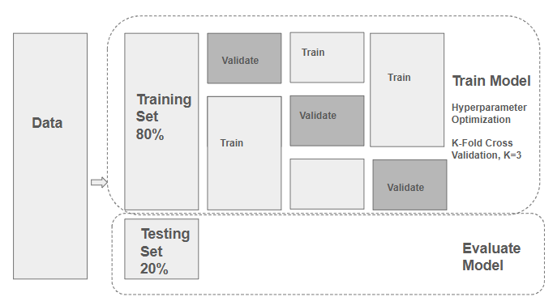
Figure 1. Model training and model evaluation workflow

3.3 Model Evaluation
Model performance evaluation is conducted on the testing dataset. The following three metrics are used to compare model performance.
Mean Absolute Error (MAE): Measures the average absolute errors between the predicted value and true value.
Root Mean Squared Error (RMSE): Represents the square root of the sum of the squared errors between the predicted value and true value.
Coefficient of Determination R² : Represents the proportion of the variance in the dependent variable (or response variable) that is explained by the independent variables (or features) in a regression model.
4. Result and Discussion
4.1 Model Performance
The results of the three models are summarized in the table below.

Table 2: Summary of model performance and comparison

Evaluation metrics | RF | GB | XGBoost | DNN
MAE | 186.97 | 206.63 | 179.43 | 331.08
RMSE | 311.43 | 324.87 | 297.90 | 500.71
R² | 0.700 | 0.673 | 0.726 | 0.225

As shown in table 2, the XGBoost model outperforms the other three models, achieving the highest R², lowest MAE, and lowest RMSE. The Random Forest model ranks second followed by the Gradient Boosting model.

The DNN model does not produce acceptable results, likely due to the small size of the datasets. The plot below illustrates overfitting in the DNN model: as the number of epochs increases, the loss on the training set continues to decrease, while the loss on the evaluation set levels off.

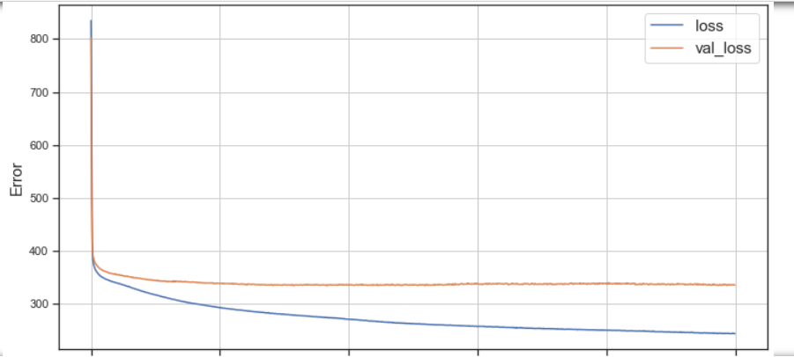
Figure 2. Loss function vs numer of epochs in training and validation set

4.2 Model explainability with SHAP analysis
A common critique of machine learning models is their lack of interpretability. Unlike statistical models, which are often more transparent, machine learning models are frequently viewed as a "black box." Shapley Additive Explanations (SHAP) is a methodology used to address this limitation. It quantifies the impact of input features on model predictions, both globally and for individual outcomes. SHAP has been successfully applied in many fields, for example [6]. In this study, SHAP is applied to the XGBoost model to investigate feature importance, feature dispersion, partial dependence, and interactions between different features.
4.2.1 Global feature importance, density, and dispersion
The average impact of different features on model predictions is shown in Figure 3.A. Latitude is the most influential feature, followed by Mean Annual Precipitation (MAP), Longitude, Study Year, and Mean Annual Temperature (MAT). Soil-related features and Basal Area (BA) also rank within the top 10.

In addition to global feature importance, SHAP analysis also reveals the impact of features on individual predictions. Figure 3.B presents a distribution plot that illustrates how features contribute to the predicted value for each data point. The color of each dot represents the feature value, and the x-axis indicates the predicted value. The plot shows that lower latitudes are associated with higher Rs values, while higher MAP and MAT values also correlate with higher Rs values.

A | 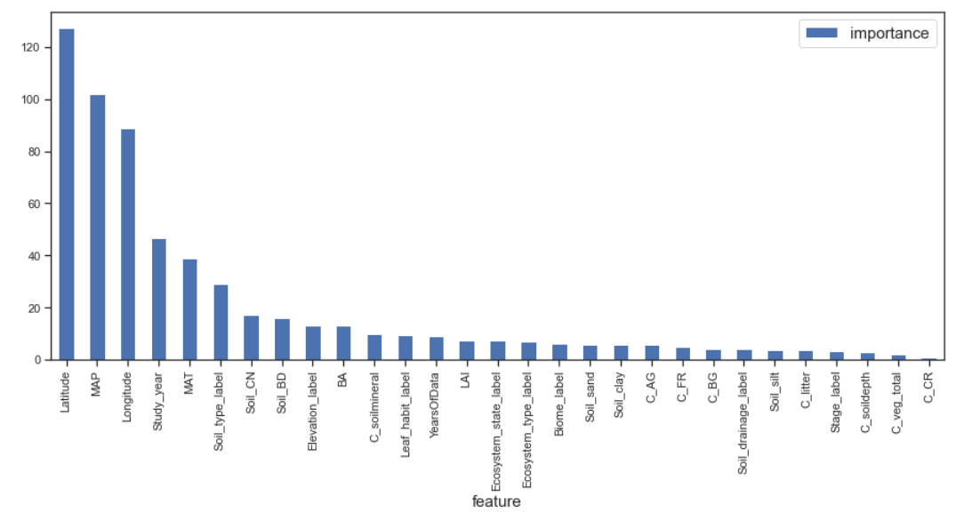
B | 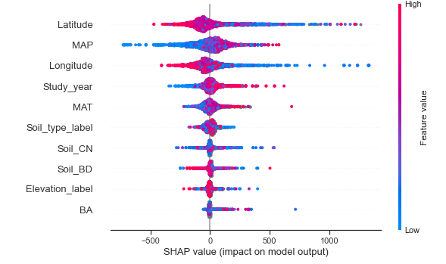

Figure 3: A) Diagram of feature importance; and B) Feature dispersion - XGBoost Model

4.2.2 Partial Dependency and interaction effect
Partial dependence plots from SHAP illustrate how the model outcome changes as a specific feature changes, while other features remain unchanged. It is a robust way to examine the relationship between input features and model predictions. Partial dependence plots can also show how two features interact with each other.
Figure 4.A shows the predicted Rs values for different MAP values across all observations in the dataset, assuming other features remain unchanged. As MAP increases up to 1000 mm, Rs increases. However, beyond 1000 mm of MAP, the predicted Rs values level off. Figure 4.B displays a slight upward trend between MAT and Rs. Figure 4.C illustrates that when both MAT and MAP are low, predicted Rs values are also low. High MAT and MAP lead to higher Rs. However, when MAT is moderate, the positive correlation between MAP and predicted Rs becomes less pronounced.
Figure 5.A shows a clear upward trend between study year and predicted Rs, indicating higher Rs in recent years. Figure 5.B illustrates the relationship between Leaf Area Index (LAI) and Rs. LAI is an index that measures leaf coverage at a site; a higher LAI value signifies a denser canopy with more leaves per unit of ground area. The figure shows that as LAI increases, Rs also increases.

A | 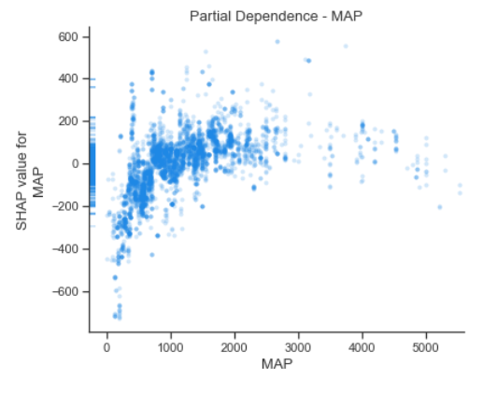 | C | 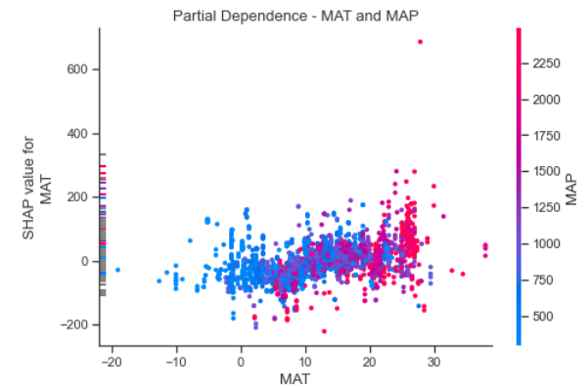
B | 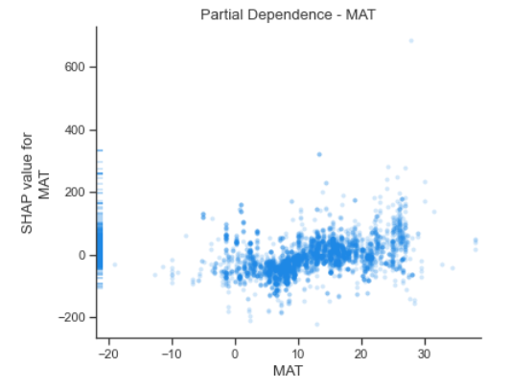
Figure 4: A) Partial dependence with respect to MAP; B) with respect to MAT; and C) interaction between MAT and MAP.

A | 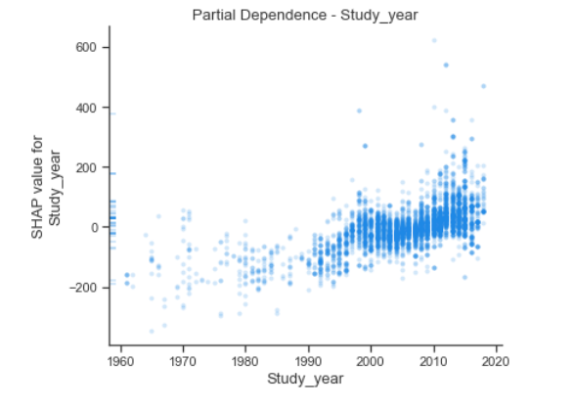 | B | 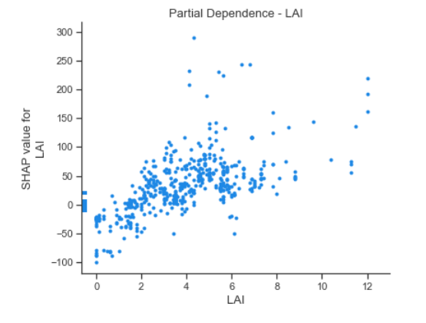

Figure 5: A) Partial dependence with respect to study year; B) with respect to LAI

4.2.3 Force plot
SHAP force plot visualizes how different features influence the model prediction for a specific observation. The features driving the prediction higher are in red and the features decreasing the predicted value are in blue. Figure 6 shows the top features in driving Rs higher for this observation are Longitude, Soil_sand, Soil_silt. However, Latitude, MAP, LAI and Study Year, impact the results negatively.
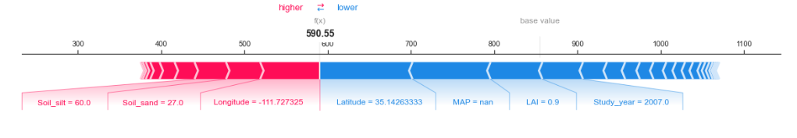
Figure 6. Force plot of a specific prediction
4.3 Model comparison
Two models in forecasting soil respiration are developed: XGBoost and Deep Neural Network. Random Forest model and Gradient Boosting model are used as baseline models for performance comparison.
The XGBoost model yields best performance with lowest MAE, MRSE and highest R². It outperforms the Random Forest model that is suggested in current literature [4, 5]. The DNN model is not able to achieve good results, primarily due to limited data.
Key learnings in the model developments are summarized below.
- Unlike the Random Forest model and the DNN model, the XGBoost model handles missing values internally and does not require imputations. This feature makes the XGBoost model more robust to missing values.
- Excluding outliers in Rs_annual boosts model performance significantly. After excluding the outliers in Rs_annual, the performance of the XGBoost model and the Random Forest model increases from ~60% to ~70%.
- The DNN model is extremely sensitive to outliers and a normalization layer is required to be added in the model. In contrast, both the XGBoost model and the Random Forest model are less sensitive and do not require normalization. Without excluding outliers, both models achieve an R² of over 60%.
- The failure of the DNN model suggests the need in obtaining more data.
4.4 Model limitations
This study has several limitations. First, the sample size is relatively small. The original dataset contains 12,272 observations, but only 6,379 remain after removing data with quality issues and outliers. Second, many vegetation and carbon-related features have missing values, which may impact model performance. Third, the database is compiled from published studies, and its coverage is therefore limited.
5. Conclusion
In this work, a new model, XGBoost, is developed to predict annual Rs from spatial, temporal, climate, and other independent variables. In addition, a DNN model is experimented. The models are compared with two baseline models, Random Forest (RF) and Gradient Boosting (GB), which are found in previous work. The XGBoost model yields the best results, outperforming the Random Forest model and Gradient Boost model. However, the DNN model is not able to obtain reasonable results, mainly due to the small sample size. Additionally, SHAP is demonstrated to be a robust method for providing model explainability, assessing the impact of features on model outcomes both globally and for individual observations.
As noted earlier, vegetation and carbon-related features have a significant number of missing values. Due to time and resource constraints, alternative data sources have not been explored. Median imputation is used to address missing data. As a next step, we plan to explore other data repositories, such as ERA5.
References

[1] Lawrence, D. M., et al. (2019). The community land model version 5: Description of new features, benchmarking, and impact of forcing uncertainty. Journal of Advances in Modeling Earth Systems, 11(12), 4245–4287.
[2] Lienert, S., & Joos, F. (2018). A Bayesian ensemble data assimilation to constrain model parameters and land-use carbon emissions. Biogeosciences, 15(9), 2909–2930.
[3] Ito, A. (2019). Disequilibrium of terrestrial ecosystem CO₂ budget caused by disturbance-induced emissions and non-CO₂ carbon export flows: A global model assessment. Earth System Dynamics, 10(4), 685–709.
[4] Liu, J., Hu, J., Liu, H., et al. (2024). Global soil respiration estimation based on ecological big data and machine learning model. Scientific Reports, 14, 13231. https://doi.org/10.1038/s41598-024-64235-w
[5] Lu, H., Li, S., Ma, M., et al. (2021). Comparing machine learning-derived global estimates of soil respiration and its components with those from terrestrial ecosystem models. Environmental Research Letters, 16(5), Article 054048. https://doi.org/10.1088/1748-9326/abf526
[6] Luo, H., Xiang, C., Zeng, L., et al. (2024). SHAP-based predictive modeling for 1-year all-cause readmission risk in elderly heart failure patients: Feature selection and model interpretation. Scientific Reports, 14, 17728. https://doi.org/10.1038/s41598-024-67844-7

